Comparison Between TCP and UDP Server

=====================================

open a terminal in the Ubuntu

1. install iperf3

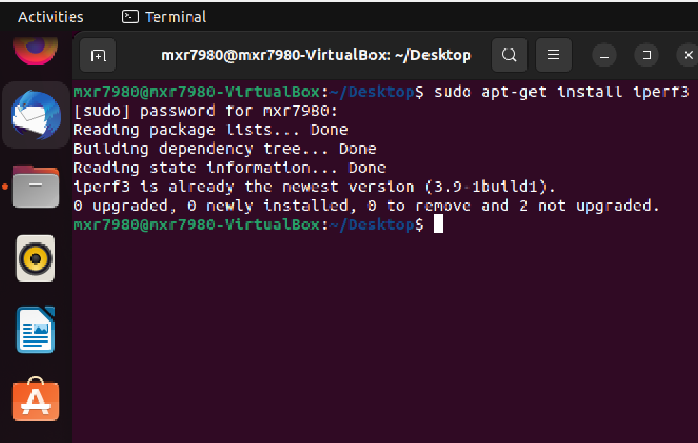

1. Open iperf3 in server mode: The server is now waiting in the listening mode

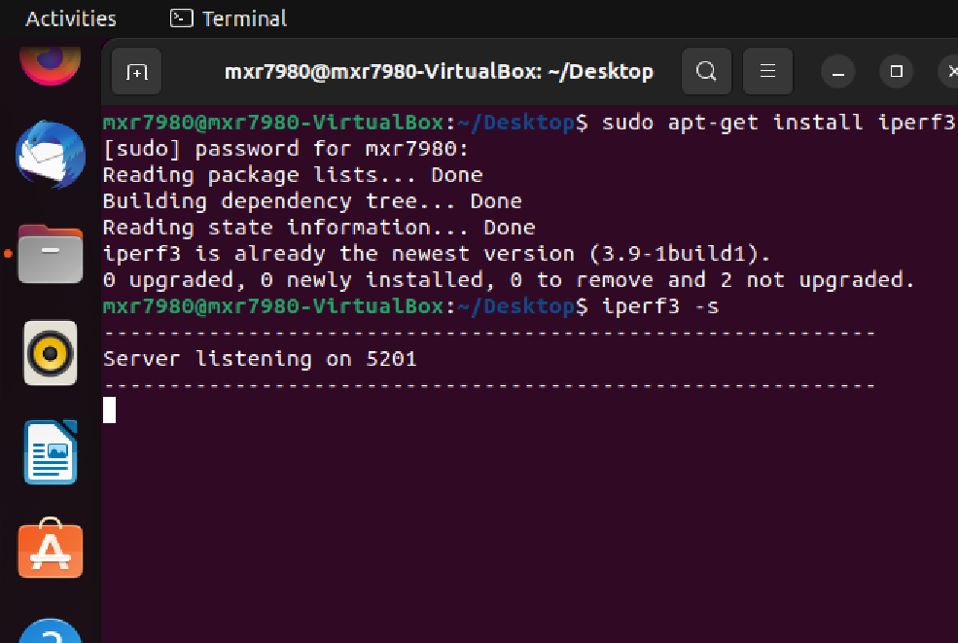

1. Computing the throughput from the client to the server in **TCP mode:**

**From Client to Server**

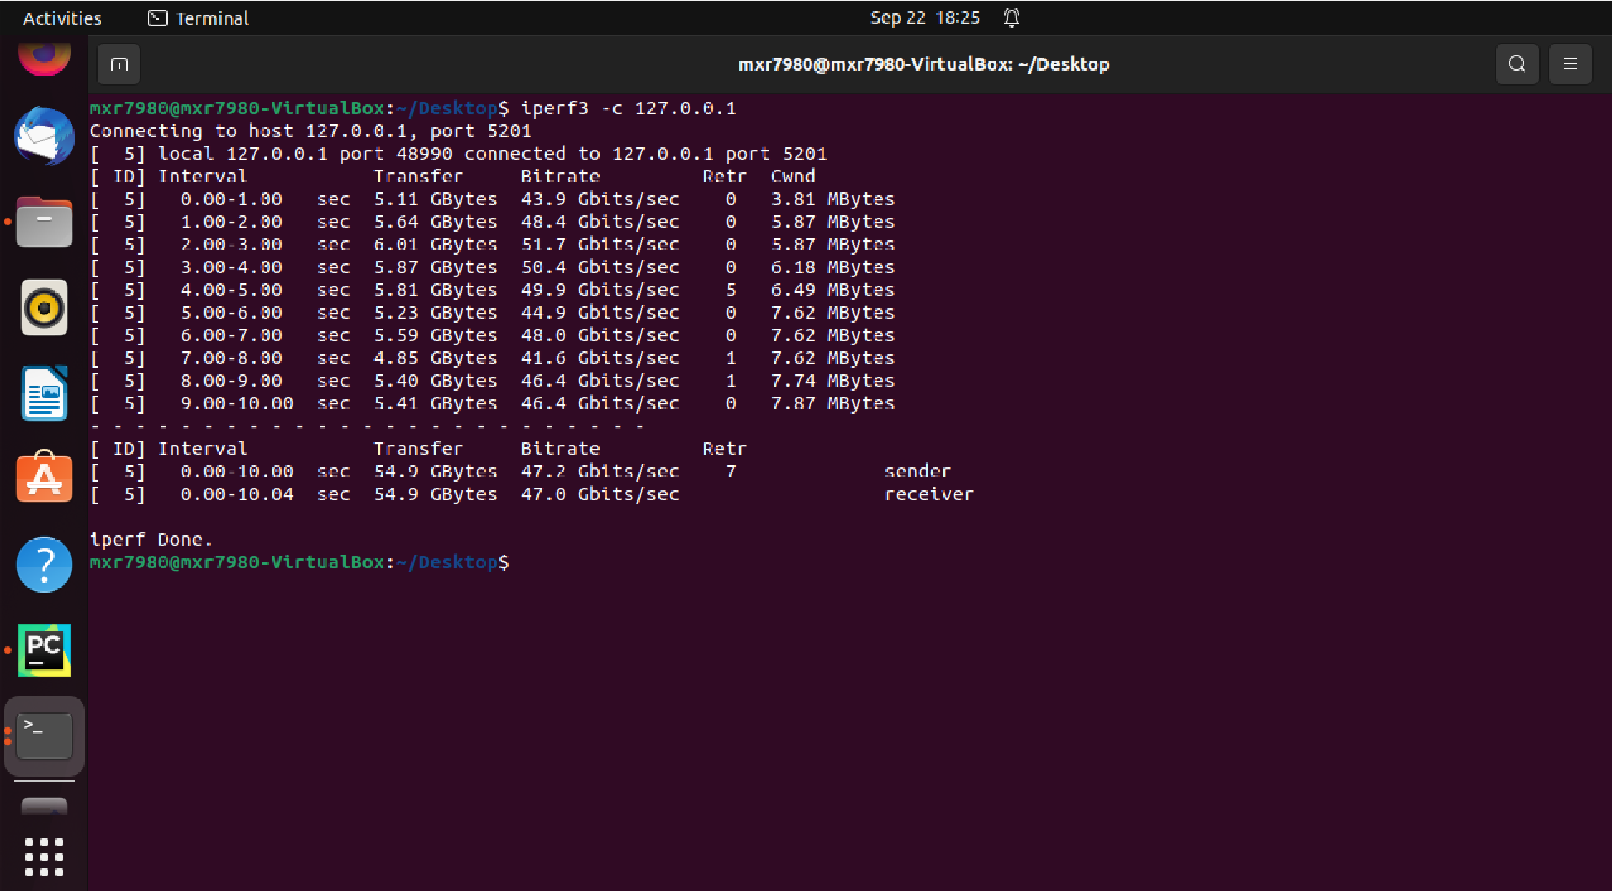

**From Server to Client**

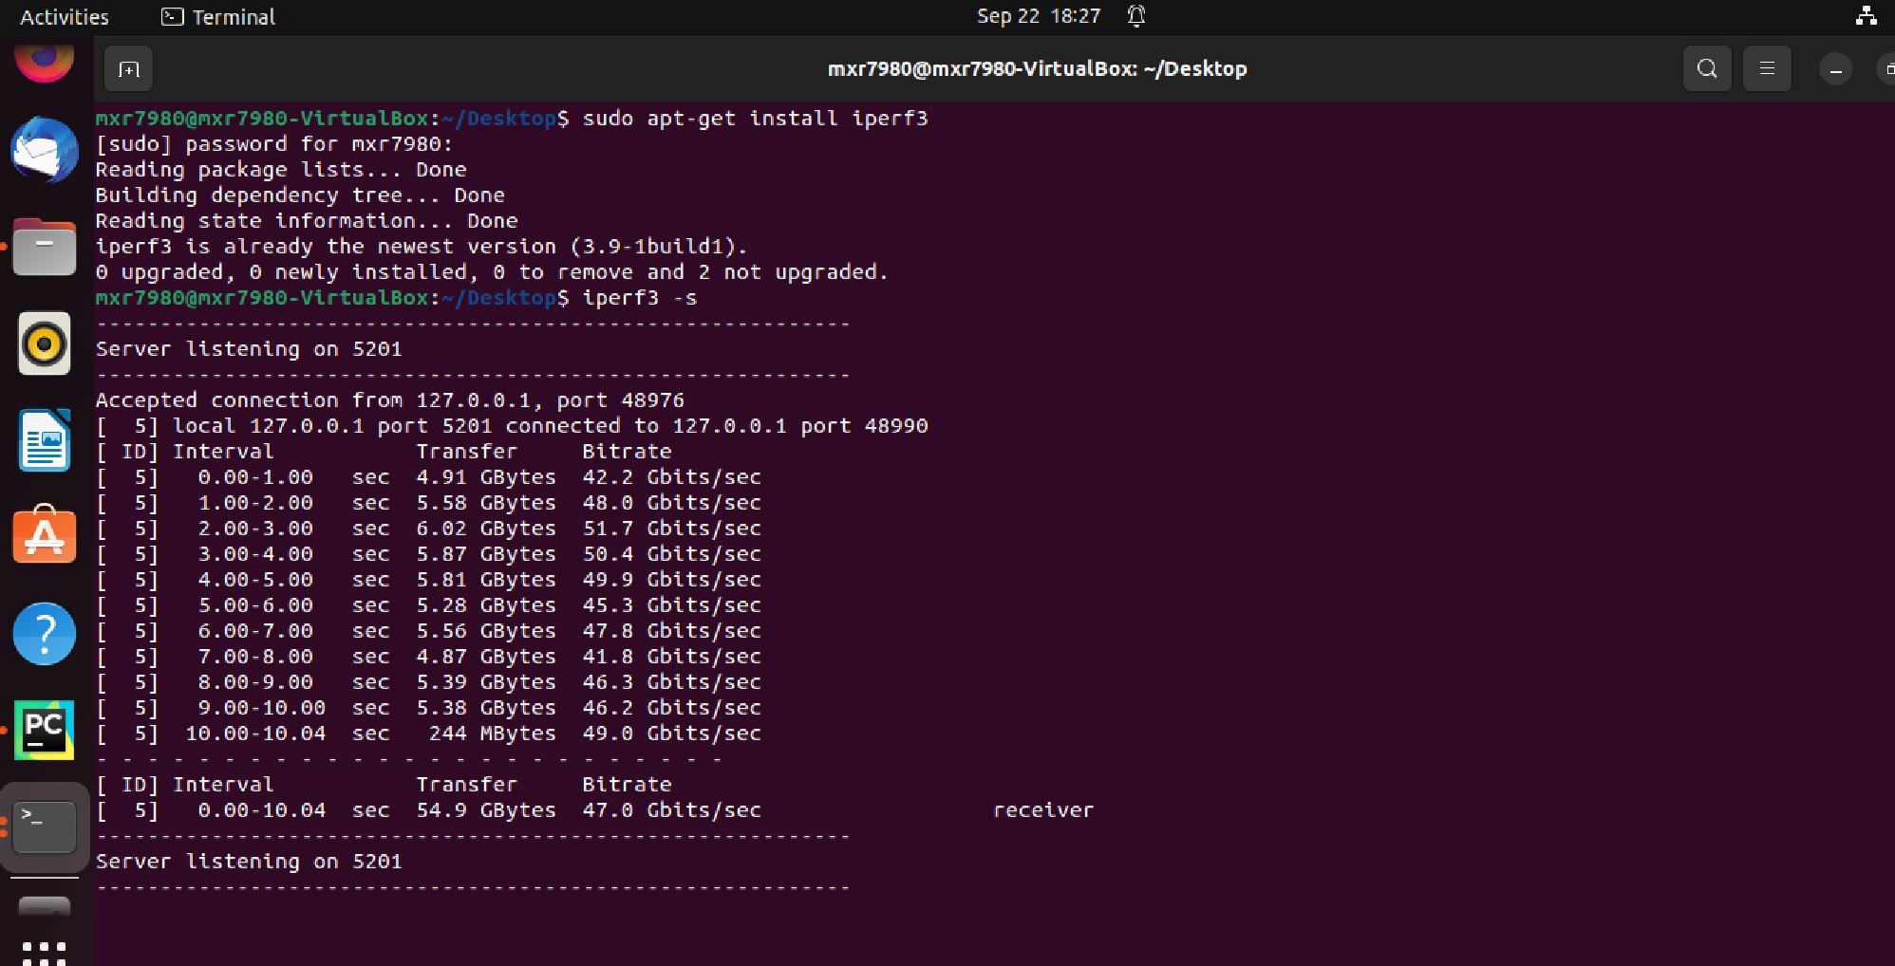

1. Computing the throughput from the client to the server in **UDP mode:**

**From Client to Server**

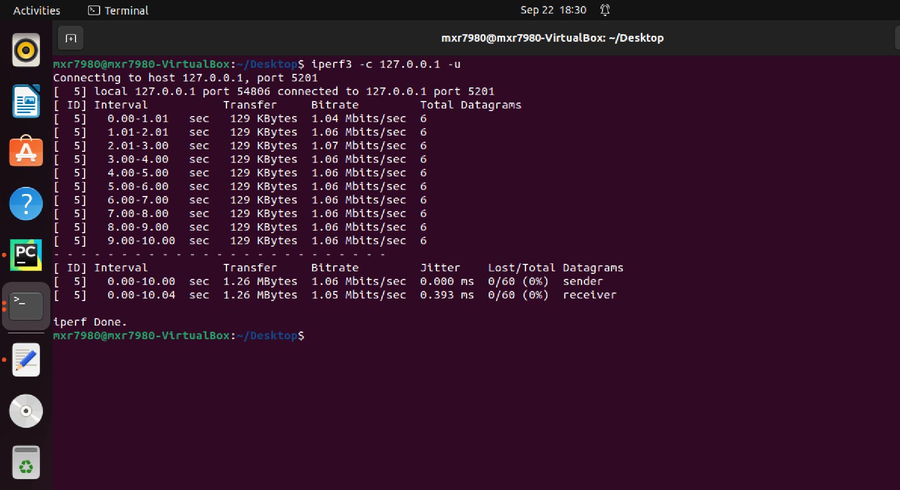

**From Server to Client**

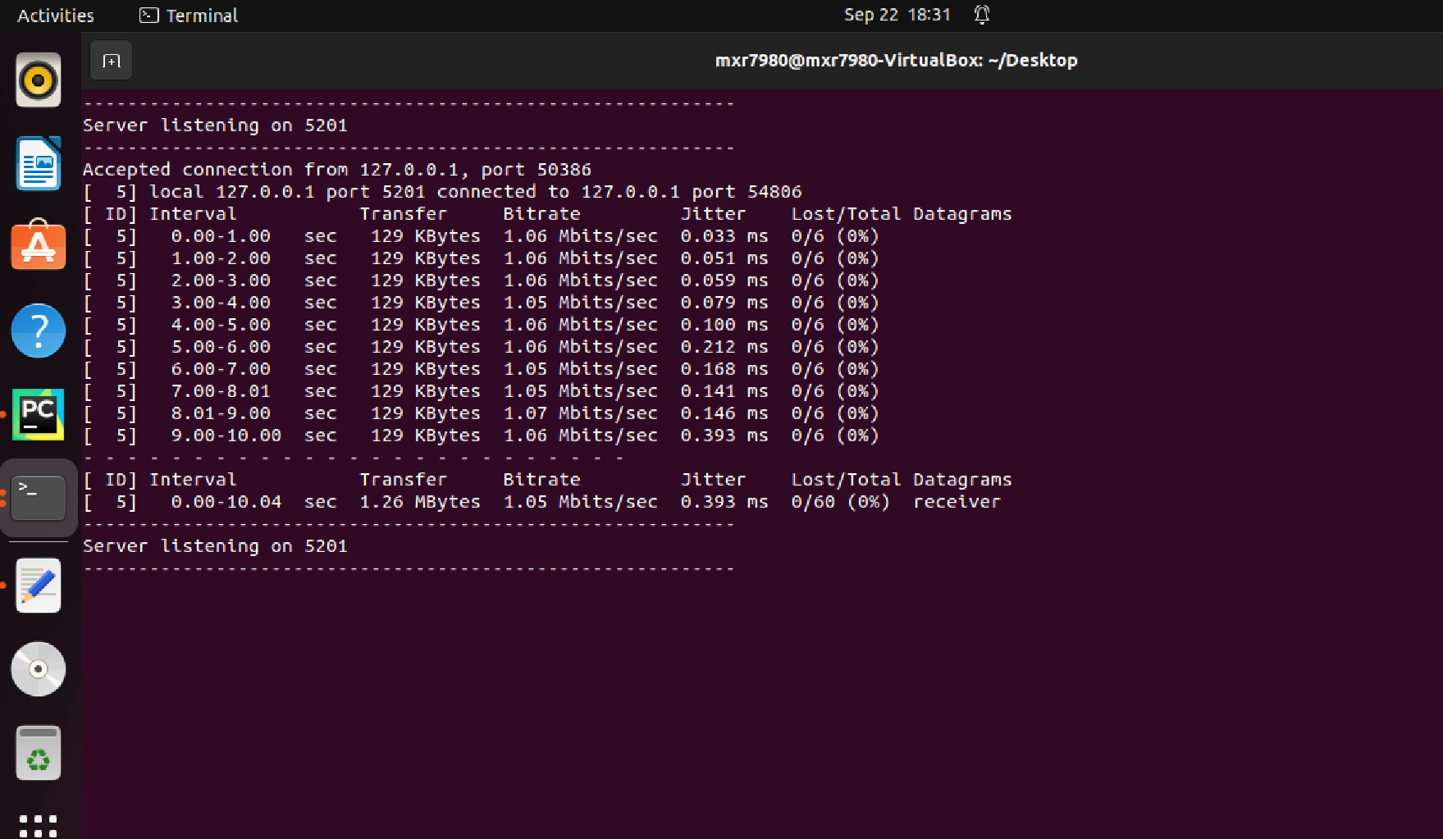

1. Capture the data from both TCP and UDP and plot that to the Python code.
2. To run that python code, open a terminal run

python3 Comparison_TCPvsUDP.py